Design for Problem 2 Day 5 (HW)
- The program will show how many years Max can spend $54,000 a year before he can no longer withdraw $54,000 a year. Starting from year 0 and with $1,000,000.
- Examples
  - N/A
- Pseudocode
Define main function:
Initial amount = 1000000
Years = 0
Stop amount = 0
While the current amount is greater than 0:
Current amount = current amount - $54,000
Years = years+1
print (years -1 ) #compensate for the fact that you start at year=0
call main function to execute program

- Variable(s)
  - currentAmt
  - years
  - stopAmt

- Python Statements
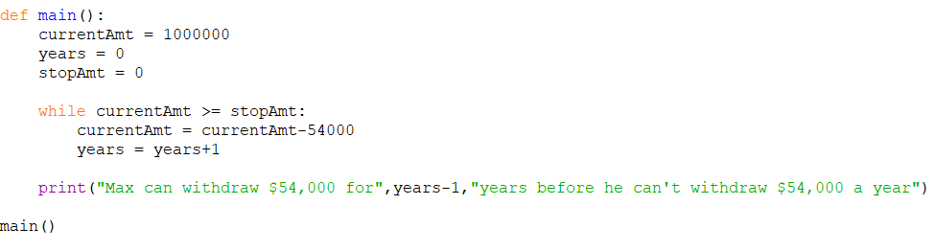
- Inputs and Outputs
  - Input – N/A
  - Output – years (int)
- Python Code (turned in as .py file)

